ABOUT US
The Justice Development and Peace Commission (JDPC) of the Catholic Diocese of Bauchi is the diocesan structure mandated to promote justice, peace, human dignity, and integral human development in line with Catholic Social Teachings. Established as the policy-making, coordinating and supervisory body for the Diocese’s social development programs, the Commission operates under the direct authority of the Bishop.
The organization started in 2003 and is registered with Corporate Affairs Commission of Nigeria (CAC) in 2016 with the name: Justice Development and Social Cohesion Initiative (JUDSCI) with registration number CAC/IT. No. 90258. JDPC works with communities across Bauchi and Gombe States, reaching all people irrespective of religion, ethnicity, or political affiliation, with particular focus on vulnerable and marginalized groups. Guided by its vision of a just and peaceful society and its mission of promoting human development, good governance, and interreligious tolerance, the Commission implements interventions across WASH, peace building, good governance, sustainable agriculture, women and youth empowerment, and prison ministry. Over the years, the Commission has built strong partnerships with government institutions, civil society organizations, and faith-based actors to advance social cohesion and community resilience.
OUR VISION
To build a just and peaceful society where unity, human dignity, and respect for life are upheld, and people are empowered with hope and joy in all creation.
OUR MISSION
We are a faith-based organization committed to promoting integral human development through capacity building, good governance, and collaboration that fosters social and religious tolerance.
OUR CORE VALUES
- We love, care and have respect for human dignity irrespective of belief.
- We cherish unity and peaceful co-existence among all.
- We value accountability and transparency based on responsibility entrusted to us.
- We value the promotion of equality and quality services.
- We cherish the protection of the environment.
- We value teamwork to empower communities towards self-reliance and just society.
- We value the protection of life.
- We value education, rural/urban development and quality health services.
IMPACT DATA
Total Beneficiaries: 35,000 households
Communities Reached (currently served): 60 communities; 8 LGAs of Bauchi and Gombe states
Active/Completed Projects: 10(completed)
AREAS OF WORK
- Water, Sanitation and Hygiene (WASH)
- Peace Building and Interreligious Dialogue
- Good Governance and Civic Participation
- Women and Youth Empowerment
- Sustainable Agriculture and Livelihoods
- Prison Ministry
SUCCESS STORIES
Problem
In Rijin Gani community of Bauchi State, women and children relied on unsafe surface water, leading to frequent waterborne diseases and long hours spent fetching water, especially during the dry season.
Intervention
JDPC Bauchi facilitated community consultations, supported the construction of 2 VIP Latrines and a borehole, and also trained a Water, Sanitation and Hygiene Committee (WASHCOM) to manage maintenance, tariffs, and accountability.
Result
- Over 350 households gained reliable access to safe drinking water
- Cases of water-related illnesses reported at the primary health center reduced
- Women saved time and energy for farming and income-generating activities
“Before, our children were always sick. Now we drink clean water, and we are not afraid anymore.” — Community woman leader
Problem
Open defecation and poor hygiene practices were common, contributing to disease outbreaks and environmental degradation.
Intervention
JDPC supported the construction of VIP latrines, conducted hygiene promotion sessions, and worked with community leaders to promote behavior change using participatory methods.
Result
- Households adopted improved sanitation practices
- Increased hand-washing and safer waste disposal
- Stronger community ownership of hygiene standards
“We now understand that sanitation is everyone’s responsibility. Our environment is cleaner, and our children are healthier.” — Youth leader
Problem
Some communities faced low trust, weak collaboration, and lingering tensions that affected collective development efforts.
Intervention
JDPC facilitated inclusive dialogue sessions, strengthened interfaith and community structures, and integrated peace and accountability principles into WASH activities.
Result
- Improved cooperation among religious and community leaders
- Joint decision-making on shared resources
- Renewed trust between communities and implementing partners
“JDPC did not just bring projects; they brought us together and listened to us.” — Chief Imam of the community
PAST PROJECTS
- Water, Sanitation and Hygiene in six local government areas of Bauchi diocese
- Legislative advocacy project
- Promoting good governance project
- Use of improved cook stove project
- Sensitization of farmers on the use of urine as an alternative fertilizer
- Promoting interfaith peace building
- Training and Establishment of Peace Clubs in Schools
- Community emergency preparedness and response teams
ONGOING PROJECTS
- Provision of potable water
- Sensitization on sanitation and hygiene
- Construction of VIP Latrines
- Facilitation of safe spaces for psychosocial support and trauma healing
- Promoting sustainable agriculture to support climate change adaptation
PROJECT BRIEF
Project Title: Enhancing Climate Resilience through WASH, Eco-Energy and Psychosocial Support
Project Status: Ongoing
Background
In many communities across Bauchi and Gombe States, daily life is shaped by hardship, uncertainty, and a lack of basic services. Families struggle with limited access to clean water, decent sanitation, and reliable sources of income. For women and children in particular, the burden is heavy, walking long distances for water, coping with poor hygiene conditions, and living with the constant risk of waterborne diseases.
The situation is made worse by a changing climate. Rains no longer come as expected, dry seasons last longer, and the land does not produce as it once did. Many smallholder farmers, already vulnerable, are losing their main source of food and income. These challenges are not just about survival, they touch on the dignity of people who want nothing more than to live healthy, peaceful lives and provide for their families.
At the same time, the use of firewood for cooking continues to damage the environment and puts women and girls at risk of respiratory illness and physical harm. There is a growing need for safer, cleaner, and more sustainable alternatives like briquettes, simple changes that can make a big difference in daily life.
Despite these challenges, there is strong community spirit and a desire for change. People want to rebuild trust, strengthen local leadership, and work together toward solutions. Access to clean water and sanitation gives families the chance to live in good health. And small steps toward environmental care, like using briquettes, are acts of justice, both for people and for the land.
This project is grounded in the reality of the communities it serves. It builds on what people already know and do, supporting them with tools, training, and structures that promote lasting change.
Project Goal
To enhance community resilience and adaptive capacity to climate change through the integration of water, sanitation, hygiene (WASH), briquette production and strengthened psychosocial support systems in Five (5) Local Government Areas of Bauchi Diocese (Bauchi and Gombe States).
Key Components:
- Climate change adaptation through sustainable water access and climate-smart dry season farming
- Promotion of eco-energy solutions, including community-based briquette production
- Promotion of sanitation and hygiene through community-led approaches, hygiene education, and strengthened WASH structures
- Psychosocial support through trauma-informed care, safe spaces, and community healing initiatives
- Community participation, capacity building, and sustainability planning
Target Beneficiaries: Rural households, women, youth, and vulnerable groups in project communities.
Expected Outcomes:
- Improved access to safe water, sanitation, and hygiene services
- Increased adoption of climate-smart agricultural practices
- Reduced dependence on firewood through eco-energy alternatives
- Enhanced psychosocial wellbeing and community cohesion
- Strengthened local capacity for sustainable development
Sustainability Approach: The project emphasizes community ownership, local structures (WASHCOMs), capacity building, and environmentally sustainable technologies to ensure long-term impact beyond donor support.

CONTACT INFORMATION
Tel: +2348138293928
Email: judscib@gmail.com
Address: St. John’s Catholic Cathedral, P.O. Box 17, Bauchi, Bauchi State.

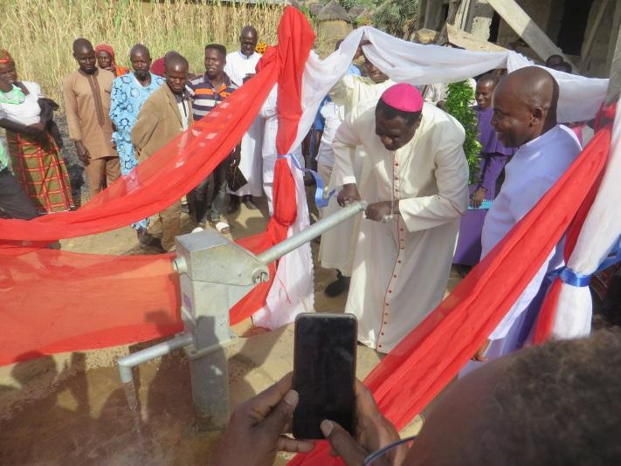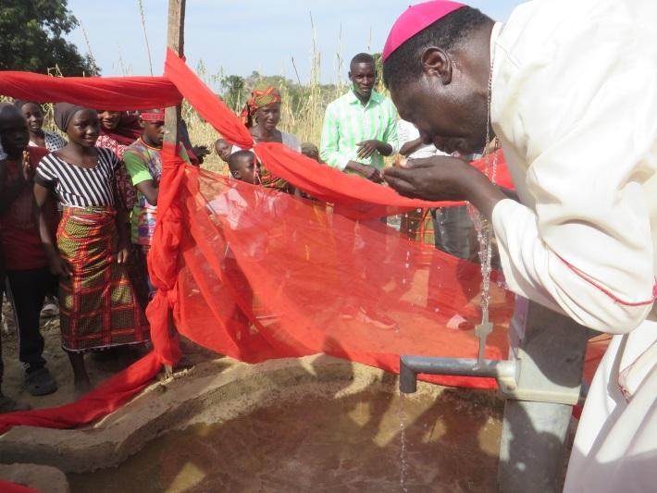
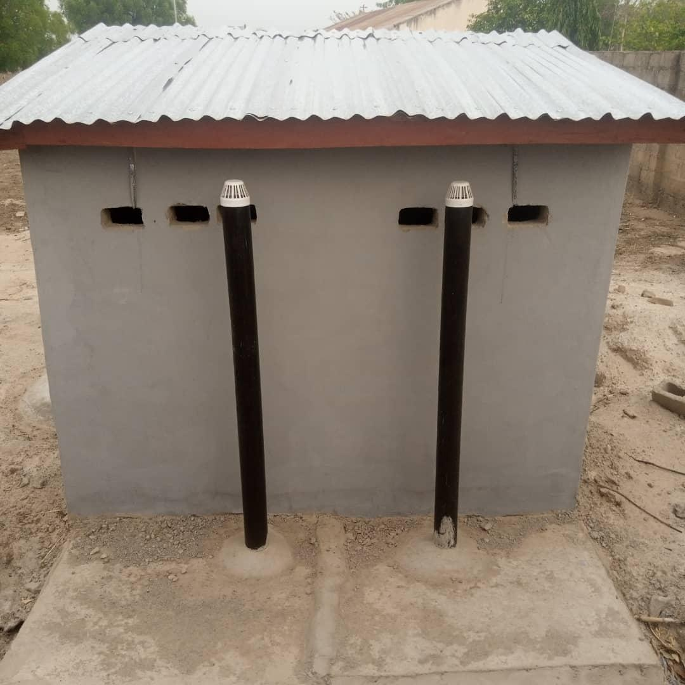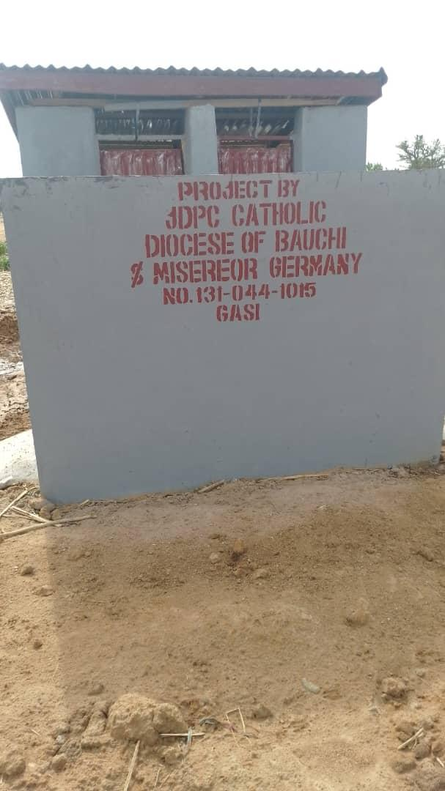
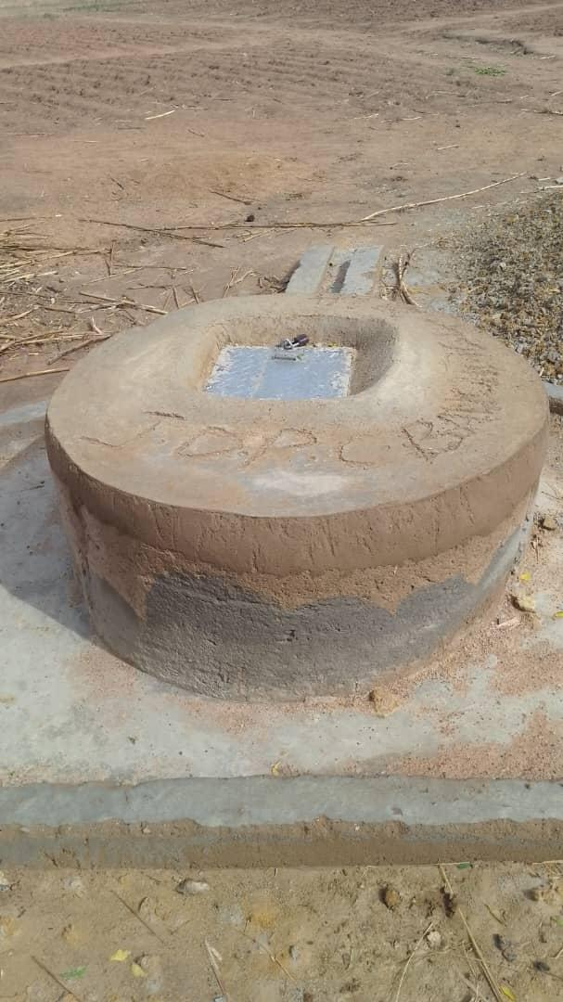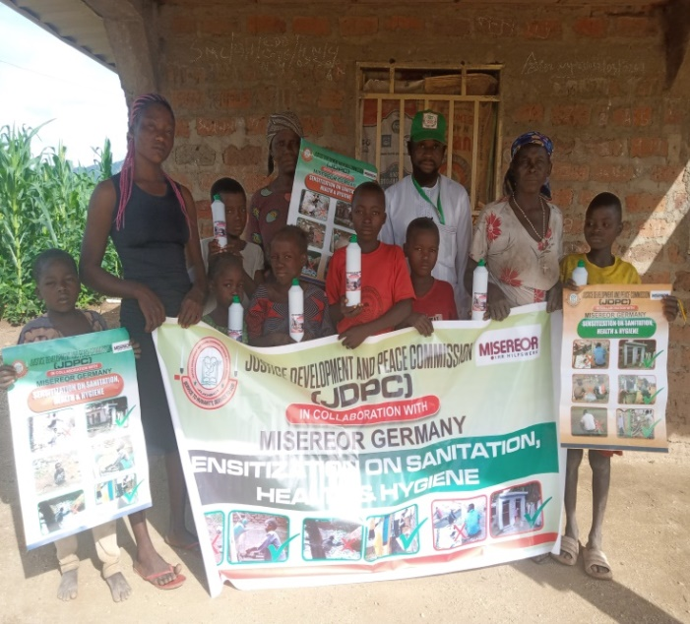
Water, Sanitation and Hygiene (WASH) Activities
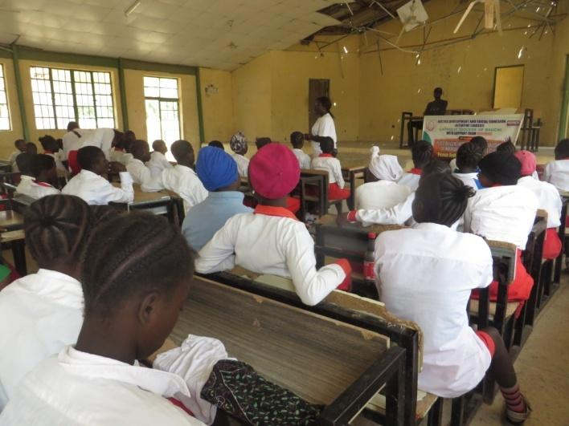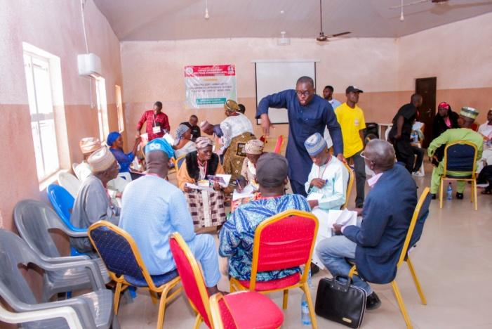
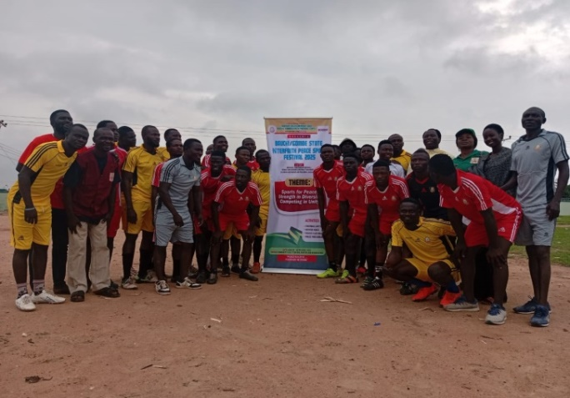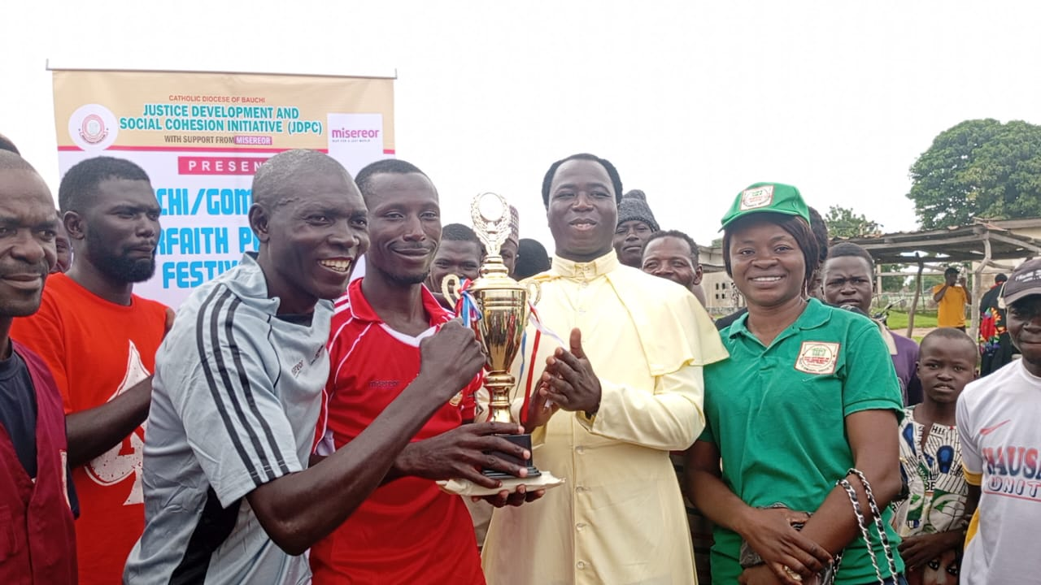
Peace Building and Inter-religious Dialogue Activities
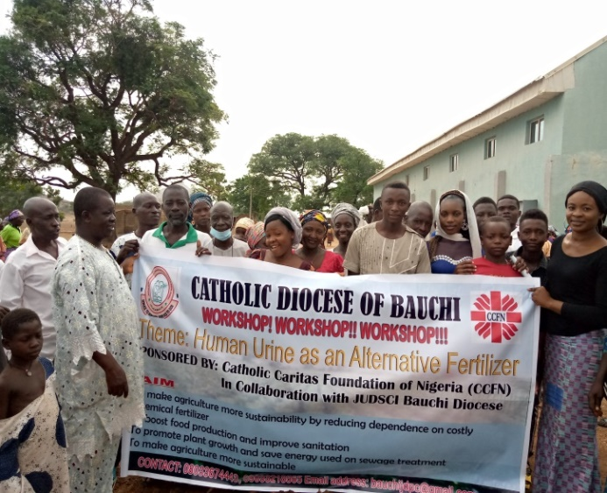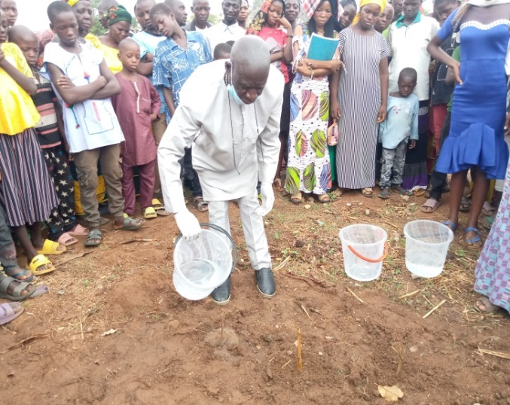
Training on the use of Human Urine as an Alternative Fertilizer

